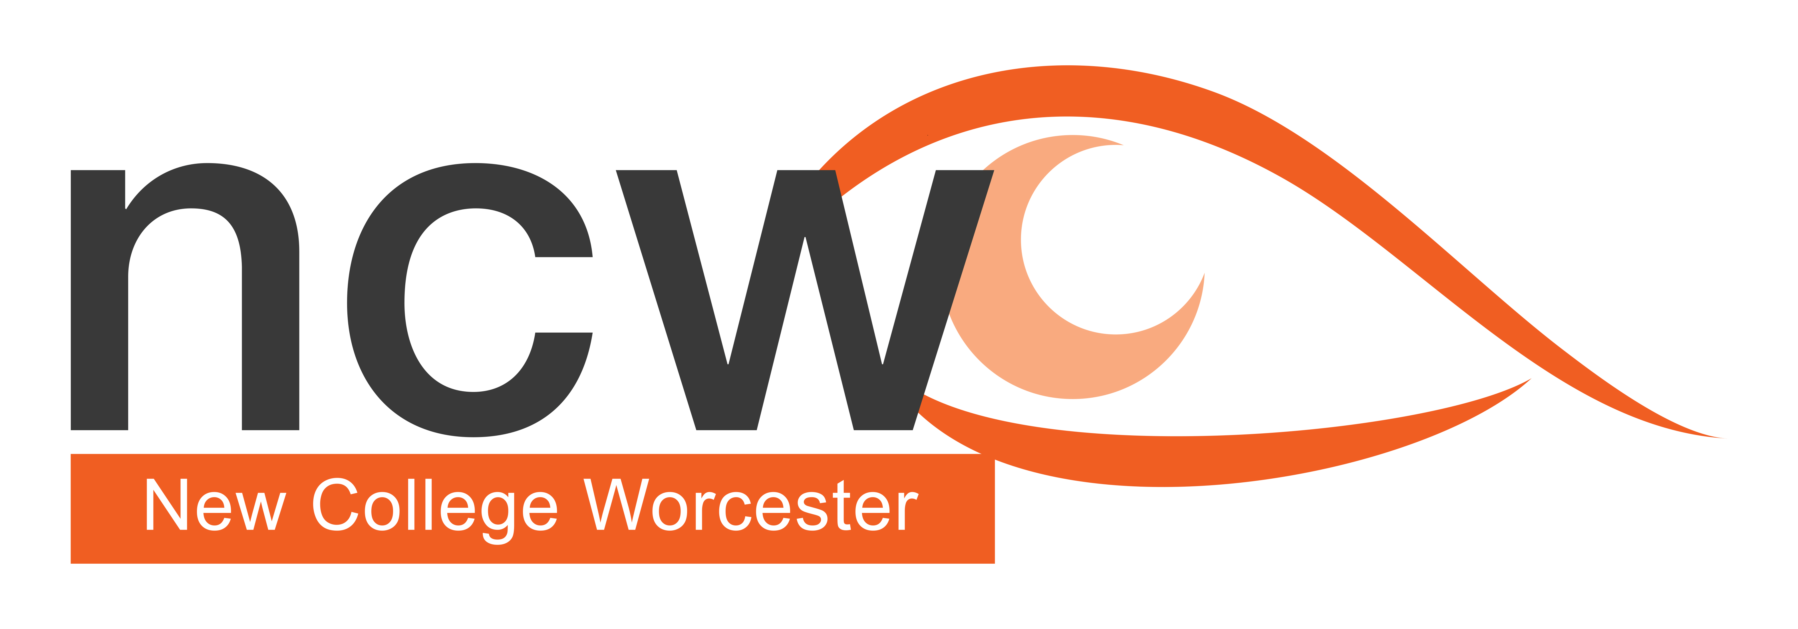

Figure 1 Photograph showing an Alexa Echo Dot

May 2024

Reaching out

**NCW Outreach Termly Bulletin — Supporting V.I. Education**

In this issue:

3D Printing Project (link to CFVI Areas1 and 7)

Upcoming Courses

Outreach Profile

## **3D Printing Project**

Staff at New College Worcester have been involved in a project with the National Archives at Kew to create 3D-printed tactile versions of four of their documents. This edition of Reaching Out looks at the Project which has highlighted for us the potentials of 3D printing. Materials were created in collaboration with George Rhodes from All Able. We have included descriptions of the workshop and would encourage other schools to get involved.

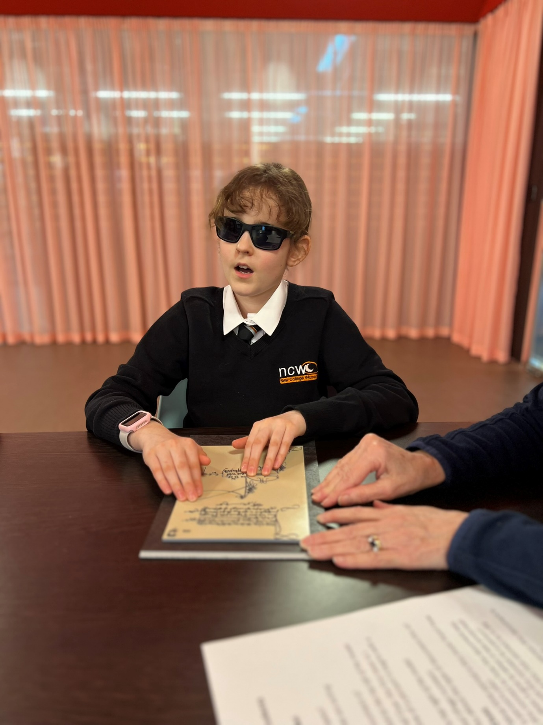

Figure Photograph shows a student reading the 3D tactile version of John Blanke's wage slip.

Photocredit: The National Archives

Tactile images by George Rhodes

George Rhodes is working on a PhD aiming to improve access to tactile maps and diagrams through the use of 3D printing. His work focuses on reducing the barriers for creators, using a new process which can convert images into tactile 3D prints. The process does not require any specialist software and is relatively easy to learn. George’s hope is that if you have access to a 3D printer, you can create useful tactile alternatives.

To support the workshop, George customised and printed several tactile resources ready for the students to interact with on the day. Starting with scans of the originals George highlights key elements, such as landmarks, crowds, or figures, marking these to be extruded into 3D shapes, bringing them literally off the page. After adding in additional content such as Braille labelling, or new textures to represent green spaces or rivers, the diagrams are ready for printing.

George commented on the workshop saying “It was a true pleasure to see all the effort of this research turn into something that is actually making a difference to real people. Seeing the kids not only being able to read and interact with these historical documents but have fun doing so was very rewarding”.

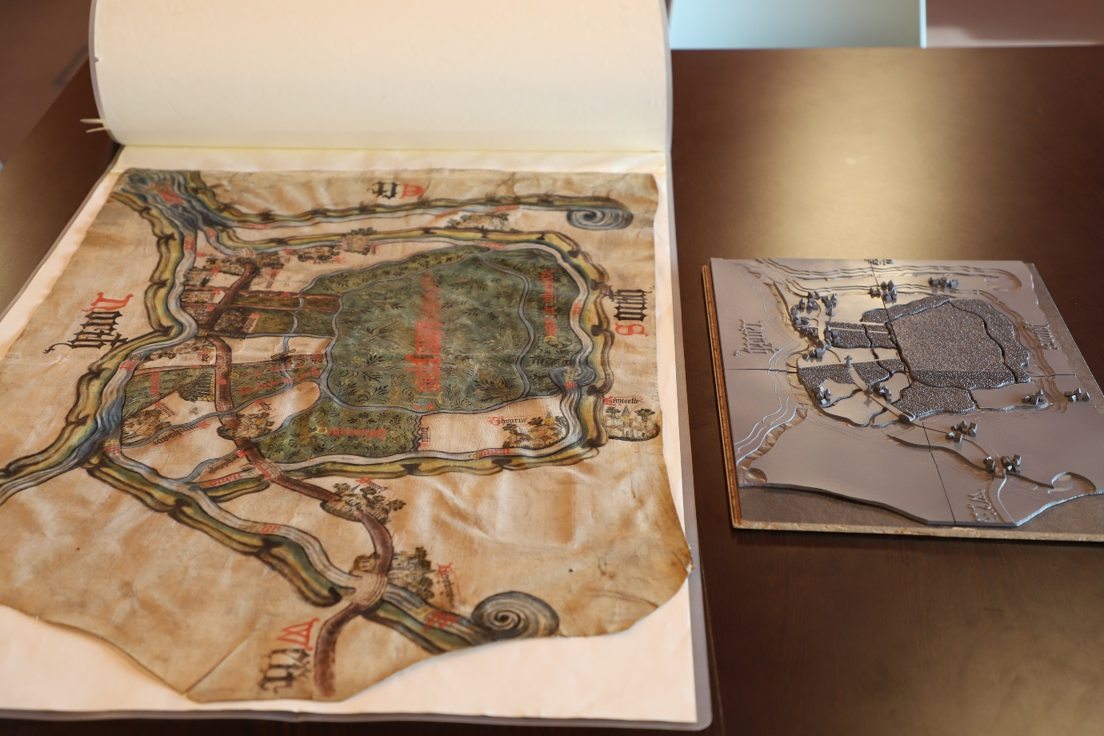

Figure The picture shows the original print version of a 1407 land ownership map with the tactile 3D representation beside it. The large letters with directions are raised with areas of land, rivers and streams shown. The shapes of buildings have been raised

Photocredit: The National Archives

## New College Worcester at The National Archives by Ellen Oredsson, Digital Projects Officer, TNA.

On 28 March 2024, I had the pleasure of welcoming a group of students and their teachers from New College Worcester to The National Archives for a full day of exploring archives from across history.

As part of the Education & Outreach department at The National Archives, I submitted a project to the TNA/RLUK Professional Fellowship Scheme 2023-24 to investigate how we can make archives not just accessible but fun and engaging for audiences with a vision impairment. The research I did eventually culminated in the creation of a full-day pilot workshop trialled by New College Worcester.

The day started with a tour of our repositories - the large rooms where the majority of our more than 12 million historical records are stored. Although these tours are not typically part of our onsite workshops, we felt it was important to include this element to help the students get a better sense of our building and collections.

After a lunch break, the workshop itself started by learning more about the Archives and our origin story involving Henry Cole’s rat. Each table got a treasure chest that they opened to find a fluffy rat toy (with warning given beforehand that it was not real!). They then got an archival document box full of different material samples, such as leather and parchment, that they had to match up with the correct material description.

Students were divided into four groups, each assigned a historical document to become ‘experts’ on. They were first introduced to their document through the corresponding tactile image and explored it with some guiding questions from their teachers.

Students were then given bags with hints in them that could give them ideas about the context of their document. These included small tactile objects that were related to the document – for example, a model of a trumpet for trumpet-player John Blanke’s wage slip. The bags also contained sound buttons that played recorded sounds when pressed. For example, the group investigating a document related to the Peterloo massacre heard a recording of protesters demanding universal suffrage. One group had a smell pot in their bag, containing some burnt peat to demonstrate that the medieval map they were investigating depicted peatlands.

The students were given the tactile models of their original documents back along with context sheets in large print and Braille. They were asked to prepare a presentation to the rest of the class explaining their document.

We ended with an original document showcase. Each group got to explore the actual document that they had been investigating, and then all students got to touch two special documents from our Safe Room: The Tide letter written by Elizabeth I and Henry VIII’s will. Before the workshop, we worked with our Collection Care team to establish where and how much the students would be able to safely touch the documents. They were even able to touch Elizabeth I and Henry VIII’s signatures!

I’d like to give a huge thank you to everyone at New College Worcester for such a lovely day. We couldn’t have asked for a better group of students, and they gave fantastic and helpful feedback at the end of the workshop that will help us improve it further and bring it to other students.

**Courses in the Spring Term**

Supporting Primary School Students – Friday 14th June 2024, 10am – 3:15pm Cost £80 (to include lunch and refreshments)

The day will focus on the strategies for supporting primary age children. Sessions and workshops will look at developing literacy, numeracy and living skills as well as other key skills for development.  
  
This event is suitable for teachers and teaching assistants working with a primary school aged child, or parents of a child who is vision impaired and at Primary School.

Outreach Open Day - Tuesday 25th June 2024, 10:00am – 3:00pm Cost £80 (to include lunch and refreshments)

These informal days are for education professionals who are supporting a student who is vision impaired or parents of a VI child and will give a taste of how NCW teaches students who are VI.  
There is the opportunity to meet subject teachers, as well as gain practical support and advice on specific curriculum areas of your choice. included in the cost of the day one of the charged NCW outreach courses per school year.

Preparing Tactile Diagrams – Thursday 4th July 2024,9:45am – 3pm Cost £80 (to include lunch and refreshments)

A day that focuses on producing tactile diagrams for Maths, Science and Geography. The course is suitable for education professionals who are supporting students who are vision impaired or parents of a child with a vision impairment.

Preparing for Exams – Saturday 13th July (free)

A free day for students in Y8-10 considering the arrangements available for exams.

Workshop with Q and A for students and their parents on exam regulations and modifications.

Core subject workshops exploring the skills required for succeeding at GCSE.

Workshop session on relaxation techniques for an exam season.

## **Profile** **of the National Archives and the Education and Outreach department**

The National Archives is the official archive of the UK government, holding over 1,000 years of history. We are home to millions of documents from across UK history including telegrams, letters, photographs, wax seals, scrolls, and maps. The oldest government record we hold is the Domesday Book from 1086, which was William the Conqueror’s survey of England and Wales.

One of the most unusual records we have is the preserved corpse of a nineteenth century rat with document remains in its belly – the same rat that was used for evidence by government official Henry Cole to prove that national records needed to be better taken care of. This evidence helped create the Public Records Office, which would later become The National Archives.

The Education & Outreach department in The National Archives uses our collection to engage students, educators, young people, families, and community groups. We provide a variety of services including free onsite and online workshops for school groups, activities for families, and events and projects for community groups. We have a dedicated [educational website](https://www.nationalarchives.gov.uk/education/) with over 200 online resources for educators and students based on original documents. We aim to give all these groups the same access to history as professional historians, believing in the value of primary sources and their ability to deepen our understandings of the past.

This project brought together external collaborators George Rhodes from All Able, Jeanette Normanton-Erry from New College Worcester, and advisor Kate Elizabeth Antolak. It also involved the work of people from across my department and The National Archives as a whole, most notably Hannah Carter, Rachel Hillman, and Clare Horrie from Education & Outreach and Alice Middlemiss and Ellie Quick who led the repository tours.

We are looking to trial this workshop using other tactile images with other schools and students. If you are interested, please reach out to Ellen at [ellen.oredsson@nationalarchives.gov.uk](mailto:ellen.oredsson@nationalarchives.gov.uk)