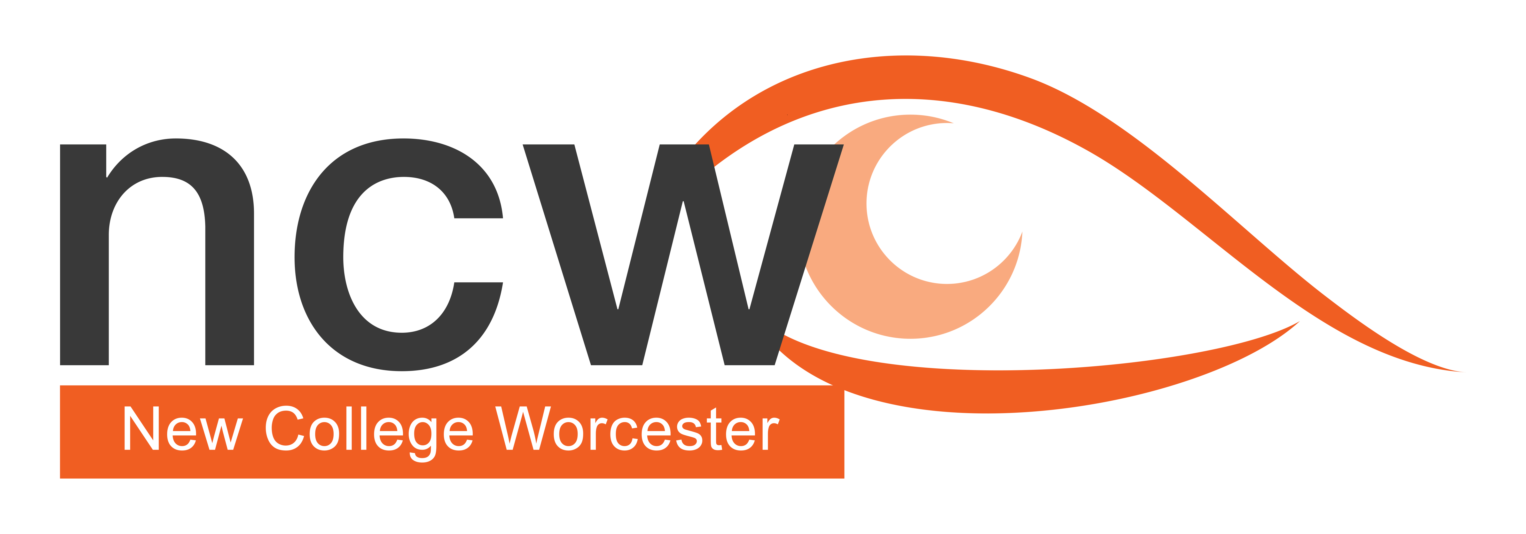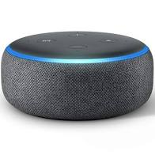

Figure Photograph showing an Alexa Echo Dot

February 2024

Reaching out

**NCW Outreach Termly Bulletin — Supporting V.I. Education**

## In this issue:

* Producing Accessible Documents (link to CFVI Area1)
* Upcoming Courses
* Outreach Profile

## **Producing Accessible Documents**

Helen Wilson, when working for Worcestershire County Council, put together SCULPT, a basic guide to producing materials which can be read easily.

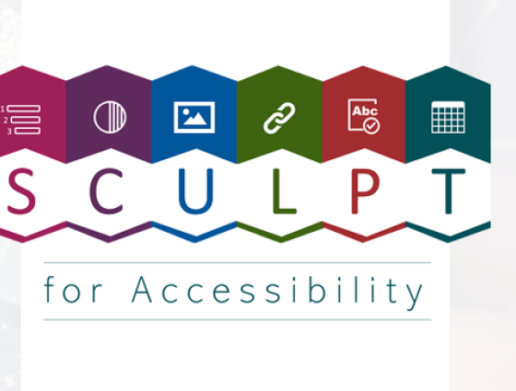

*Figure 1 The SCULPT logo which says SCULPT for accessibility*

SCULPT is based around:

S - Structure (the use of headings and styles); when used correctly they can help user who can and can't see a screen find information faster.

C - Colour and contrast; Use sufficient contrast for text and background colours: Considering colour and contrast isn't just about people being blind or having vision issues, it is important to everyone. Many people struggle to read yellow writing on a white background. Ensure that colour is not the only means of conveying information

People who are blind, have low vision, or are colour-blind might miss out on the meaning conveyed by colours alone so use other distinguishing factors too, such as labels.

U - Use of images; When text that is intended to be read is presented as an image, screen readers and other assistive technologies cannot read text that’s contained inside an image. There are four very simple things to consider when adding images to web pages or documents.

* use images that support the text
* never use an image instead of text
* use correct image sizes (on the web it is best to have images around 150kb)
* use alt text on images: Alt text is used to provide an alternative description of the image for those people who are unable to view it.

L - Links (hyperlinks): These work best when written in a descriptive way.  People who use screen readers sometimes might read the content of the page and then bring up a menu of the links separately to tab through and visit afterwards. Describe the link and where it is going as this will help the user understand where it is directing them. Do not use the full web address.

P - Plain English

Plain English is writing clearly with the reader in mind and with the right tone of voice. Plain English means avoiding using hard to understand language, such as jargon, unexplained acronyms and long words. Try to aim for an average reading age of 12. Plain English helps as many users as possible to understand your content.

T - Table structure: Poorly formatted table make it very difficult for screen readers to navigate. When using tables to present data or information make sure you use a simple table structure with column headers, making sure that the tables don't contain split cells, merged cells, or nested tables (tables within tables).

Also, consider the accessibility best practice for writing dates and times

Good accessibility practice for writing dates and times is not to use full-stops. 9.9.22 or 10.00 reads as a decimalised number to a screen reader. Dates should be written using forward slashes if you need to write them numerically – 9/9/2022. Times should be separated with a colon – 10:00.

For more information look at the Sculpt accessibility guide at Worcestershire council website

* **Courses in the Spring Term**

Supporting Primary School Students – Friday 14th June 2024, 10am – 3:15pm Cost £80 (to include lunch and refreshments)

The day will focus on the strategies for supporting primary age children. Sessions and workshops will look at developing literacy, numeracy and living skills as well as other key skills for development.  
  
This event is suitable for teachers and teaching assistants working with a primary school aged child, or parents of a child who is vision impaired and at Primary School.

Outreach Open Day - Tuesday 25th June 2024, 10:00am – 3:00pm Cost £80 (to include lunch and refreshments)

These informal days are for education professionals who are supporting a student who is vision impaired or parents of a VI child and will give a taste of how NCW teaches students who are VI.  
There is the opportunity to meet subject teachers, as well as gain practical support and advice on specific curriculum areas of your choice. included in the cost of the day one of the charged NCW outreach courses per school year.

Preparing for Exams – Saturday 13th July (free)

A free day for students in Y8-10 considering the arrangements available for exams.

Workshop with Q and A for students and their parents on exam regulations and modifications.

Core subject workshops exploring the skills required for succeeding at GCSE.

Workshop session on relaxation techniques for an exam season.

## **Profile** - **Helen Wilson**

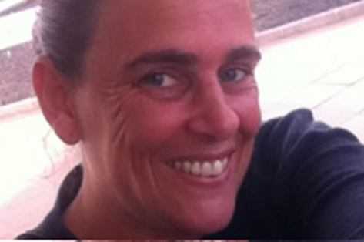As a former teacher, I believe our next generation of learners are key to steering the future of a more inclusive digital society. Having conducted extensive research, I developed a training model for digital accessibility that got adopted in my workplace, so I know it’s possible to educate people to make more accessible content for those with assistive technology needs. This model has also been adopted by New College to educate new members of their team how to make accessible materials for those with visual impairments.

These ideas have underpinned my PHD research and helped me develop something called Learn to Enable. Learn to Enable sets out 12 basic digital skills that can help people to make content more accessible for a broader range of needs. It’s a bite-sized approach so anyone, no matter what IT skills level they have, can engage with the skills and adopt them to make everyday content such as documents, presentations, videos, podcasts and social media more accessible.

If you ever observe someone using screen readers or assistive technology, it becomes very apparent the impact of barriers caused by inaccessible content. By adopting the simple skills of the Learn to Enable approach it can make a significant difference, or even be the difference between some people being able to use digital content or not. My ambition one day is to see these basic skills put onto the school curriculum for our next generation, and for teachers to be provided with this type of support to be able to create materials with the principles of accessibility applied.

## For more information go to [learntoenable.co.uk](http://www.learntoenable.co.uk/)

