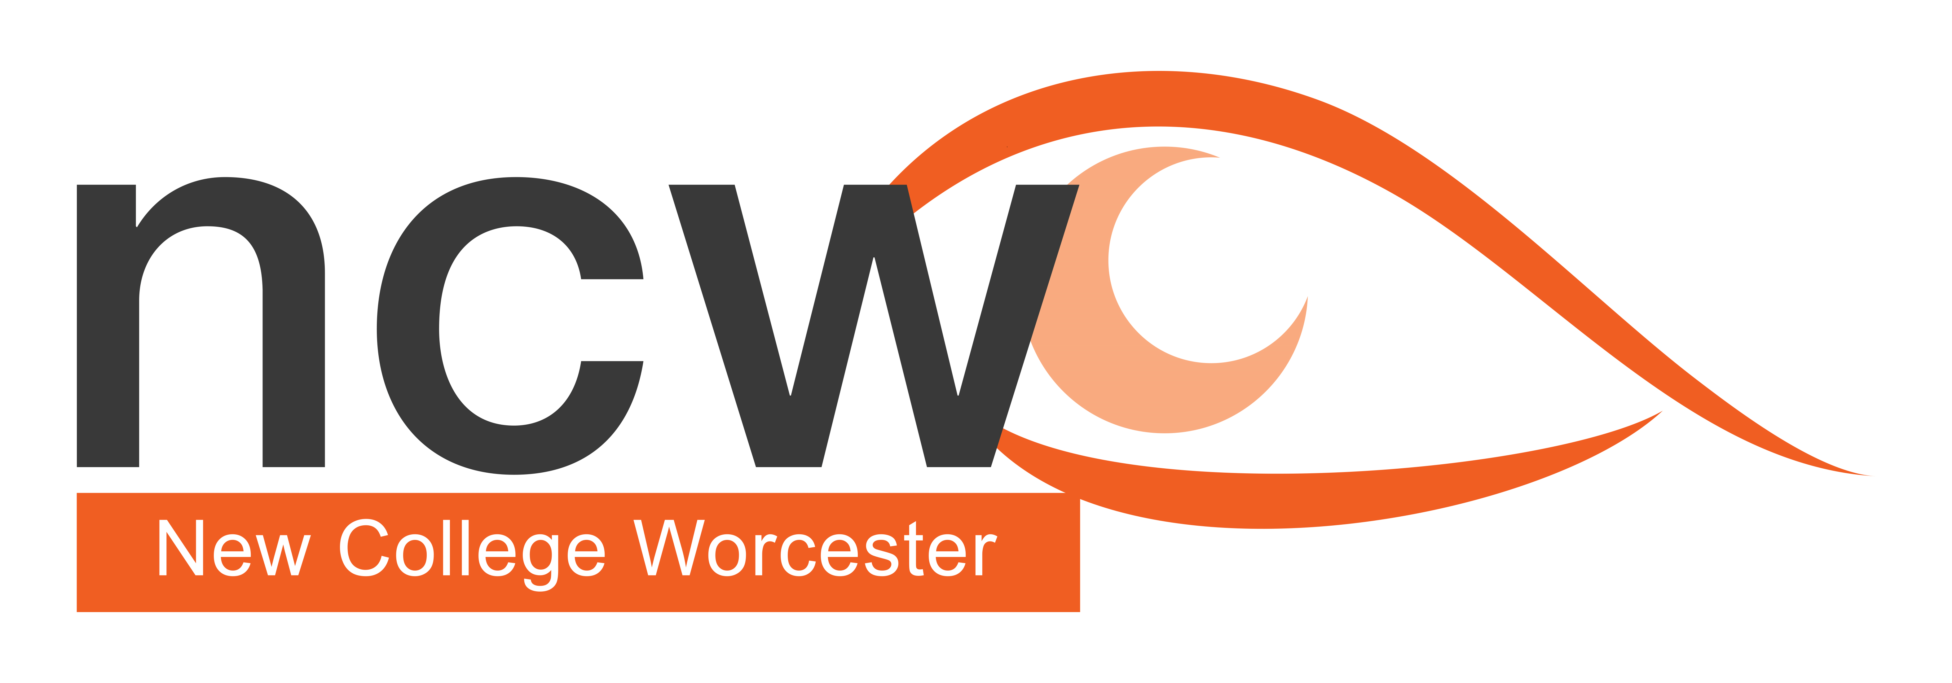

Figure 1 Photograph showing an Alexa Echo Dot

October 2023

Reaching out

**NCW Outreach Termly Bulletin — Supporting V.I. Education**

## In this issue:

* Priorities for assisting student Mobility (link to CFVI area 5)
* Upcoming Courses
* Outreach Team Profile

## **Assisting Student Mobility**

Although Habilitation professionals will be in charge of supervising formal training, in schools there are core skills that we can support which are important for the new term:

Adult Guiding of the Student

* Encourages more independence and movement for the student
* Through movement of the guide, the student can obtain information about the environment
* The guide is always one step ahead of the student so the guide reaches obstacles first
* The student grips the guide’s arm just above elbow
* The student must use a ‘C’ grip with their fingers inside the crook of the guide’s elbow and thumb on the outside of their arm
* This grip allows the student to feel your movements and stay in constant contact with you
* When guiding a student, you should guide to the back of a chair
* If the back of the chair is against the wall, then you will need to tap the front of the chair

Student encouraged to use Trailing

* They need to stand parallel to the guiding surface
* The back of the hand (knuckles) is put lightly against the object, commonly a wall
* Finger tips should be curled inwards (to protect fingers)
* Fingers are slightly apart
* Hand needs to be out in front of the body
* Keep in constant contact with surface

Upper body and Lower body protection

Lower body

* The arm is in a downwards position diagonally across the body (at about waist height) The palm faces inwards
* Can be used to locate low objects such as chair or table
* Protects against low obstacles such as table edge

Upper body protection

* Palm of hand faces outwards away from body
* It is useful for checking for doors that might be left ajar
* Should be able to blow onto wrist if the hand is in the correct position
* Student advice:
* “If I am walking with you don’t grab my arms let me take yours. I will keep a half step behind to help anticipate kerbs or steps”.
* “Don’t be overcautious and make a full stop at every step, walk normally and your body movement will tell me what to do”.
* Think about the main areas that students will use
* Landmark your rooms -
* What landmarks are there in the room which aid navigation?
* Use windows as a landmark if the student has any light perception
* Fixtures must have a permanence so students can memorise them
* Description is vital, for example it is useful for a new student to know who is in the room - always mention your name

Other things to remember:

Leave doors open or fully closed not half shut as they will be a hazard

Clutter can make areas stressful. Rooms need to be clear and uncluttered

* Encourage students not to leave chairs or bags in the middle of the room
* Chairs need to be pushed in when not in use
* Heavy bags can affect students’ mobility e.g., posture
* Noisy and busy environments can make mobility more challenging
* Are classroom doors labelled with Braille or Large Print?

Remember effective Mobility can be affected by a range of additional factors:

* Tiredness can cause disorientation
* Confidence
* Weather conditions
* Lighting conditions
* Mental Health
* Medication

## **Courses in the Autumn term**

Outreach Open Day - Tuesday 14th November 2023, 10:00am – 3:00pm Cost £80 (to include lunch and refreshments)

These informal days are for education professionals who are supporting a student who is vision impaired or parents of a VI child and will give a taste of how NCW teaches students who are VI.  
There is the opportunity to meet subject teachers, as well as gain practical support and advice on specific curriculum areas of your choice. included in the cost of the day one of the charged NCW outreach courses per school year.

Practical Advice for Supporting Vision Impaired Students in Exams – Tuesday 21st November 3:30pm – 5:00pm online (free)

The session will focus on preparing students for exams.

Looking ahead:

Don’t be Afraid of the Keyboard – Wednesday 17th January, 3:30pm- 5:00pm online (free) This session focuses on how to use to optimise the keyboard and become a proficient user by giving VI students the ability to use shortcuts and remove barriers often encountered.

Supporting the Emotional Well-being of CYP with a VI – Monday 5th February 2024 3:30pm – 5:00pm online (free)

It is not uncommon for children and young people to feel overwhelmed at times and in need of emotional support, but there is evidence to show that those with a vision impairment are more likely to experience this more often. Children and young people with VI are statistically more likely to experience depression, isolation and unhappiness.  NCW use a trauma informed approach to support the students’ wellbeing within the context of VI. This session will offer some ideas, tips and lessons learnt from supporting students at NCW.

GCSE Revision Course – Wednesday 20th – Friday 22nd March 2024

We are planning to hold the GCSE Revision course on site next Easter, (Wednesday to Friday). The course is suitable for all VI students in Years 9, 10 and 11 to help them with their revision skills and exam technique. The course is residential and there is the opportunity in the evening to socialise with their peers and have some fun.

Profile – NCW Mobility Department

**The Mobility team believe that the ability to get around our campus, and the wider world, with confidence is central to the future success of our students. We are passionate about encouraging our students to** develop transferable skills for life beyond New College Worcester. All of the skills taught are fundamental to enable our students to become confident and competent travellers who can participate in their communities and have a fulfilled lifestyle.

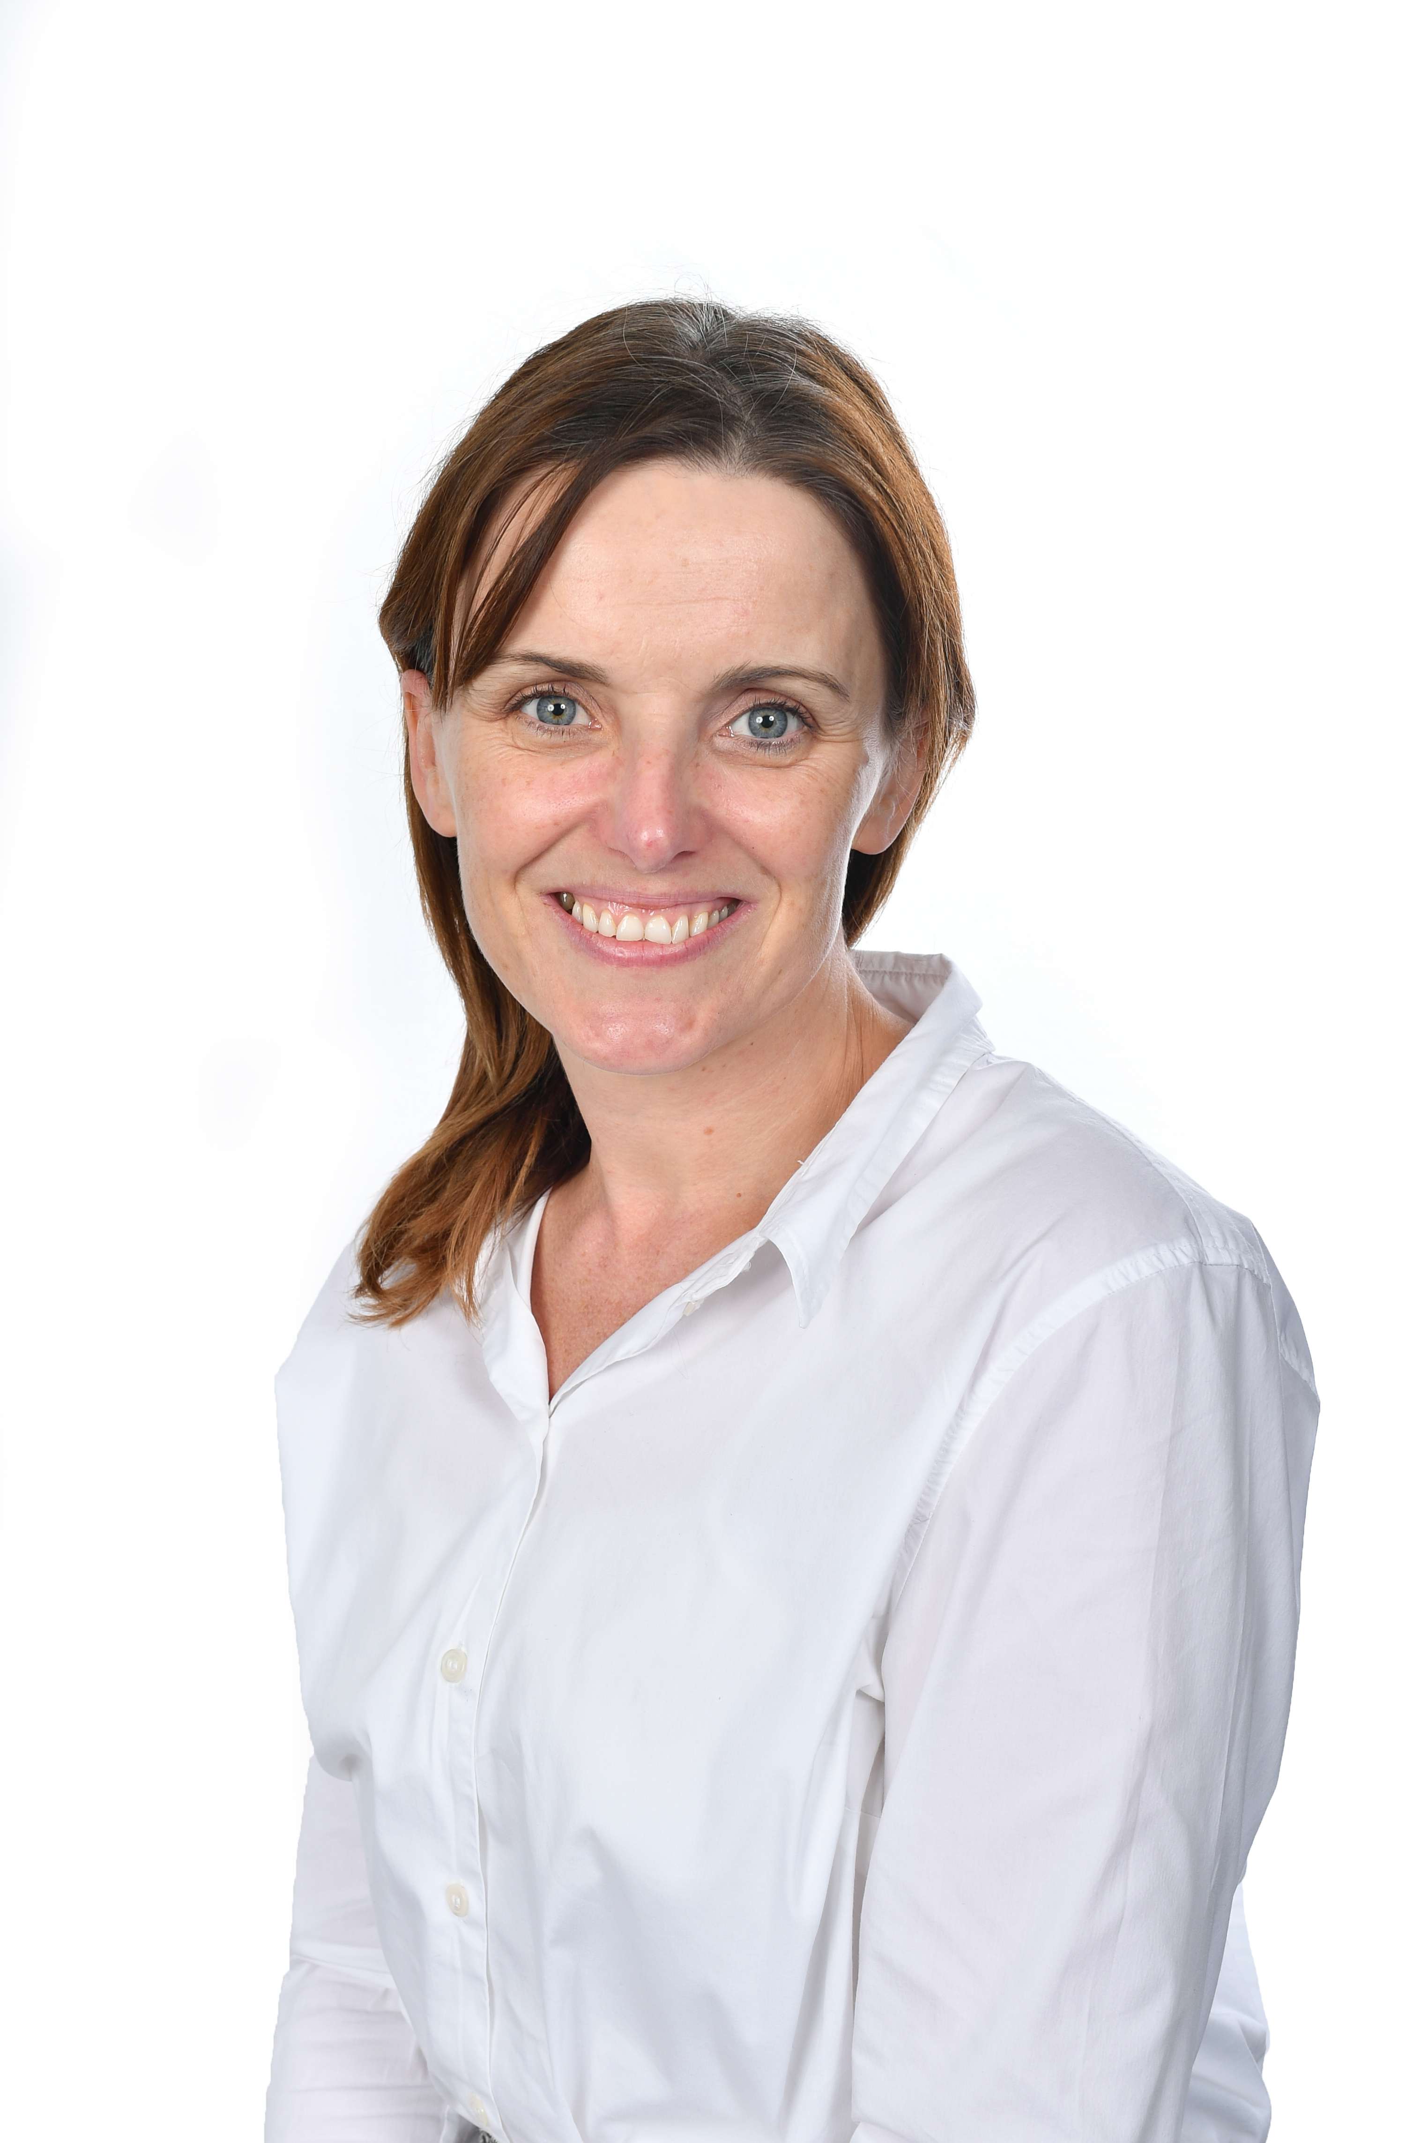

## **Katie Simkins**

## *I work as a part of a team of three mobility officer’s at NCW and am married with three children, I have worked at New College for ten years and have previously been a houseparent in Bradnack house.*

*I enjoy travel and I am learning to speak Italian and Spanish and install this passion of travel into my students. My role in my job is to ensure that students travel safely in their environment and that they ultimately gain confidence in themselves.*

*I feel very privileged to work with every child work on a one-to-one basis and every mobility lesson is student centred. I believe very strongly that when understanding a child and how they orientate within an environment it is important to understand the whole child. I have gained a distinction in trauma training and I have a degree in rehabilitation and have qualifications in psychology too. However, the greatest teacher is often the child themselves!*

## 

